**NAME : MAHAD SHAHNAWAZ**

**ROLL NO. : 24K-3057**

**DLD LAB TASK 1**

**QUESTION : 01**

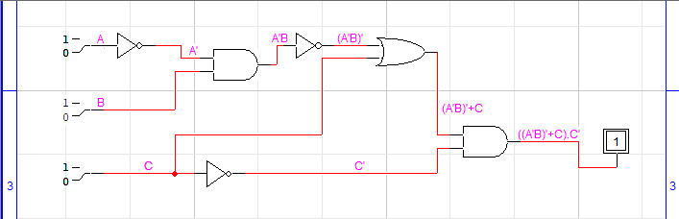

**TRUTH TABLE:**

|  |  |  |  |  |  |  |  |  |
| --- | --- | --- | --- | --- | --- | --- | --- | --- |
| A | B | C | A’ | C’ | A’B | (A’B)’ | (A’B)’+C | ((A’B)’+C).C’ |
| 0 | 0 | 0 | 1 | 1 | 0 | 1 | 1 | 1 |
| 0 | 0 | 1 | 1 | 1 | 0 | 1 | 1 | 1 |
| 0 | 1 | 0 | 1 | 1 | 1 | 0 | 0 | 0 |
| 0 | 1 | 1 | 1 | 1 | 1 | 0 | 1 | 1 |
| 1 | 0 | 0 | 0 | 0 | 0 | 1 | 1 | 0 |
| 1 | 0 | 1 | 0 | 0 | 0 | 1 | 1 | 0 |
| 1 | 1 | 0 | 0 | 0 | 0 | 1 | 1 | 0 |
| 1 | 1 | 1 | 0 | 0 | 0 | 1 | 1 | 0 |

**QUESTION : 02**

**a)**

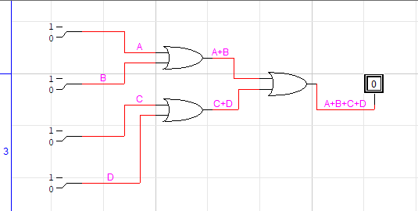

**b)**

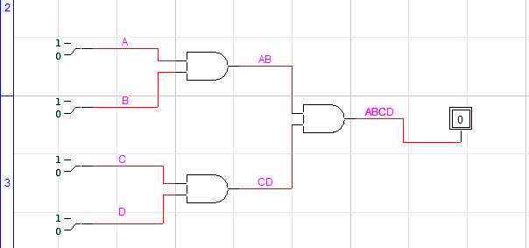

**c)**

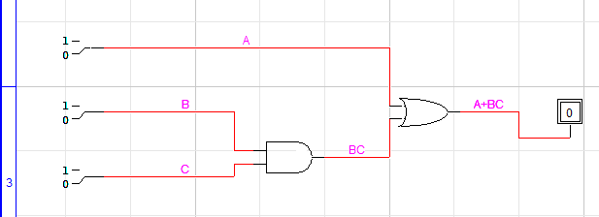

**d)**

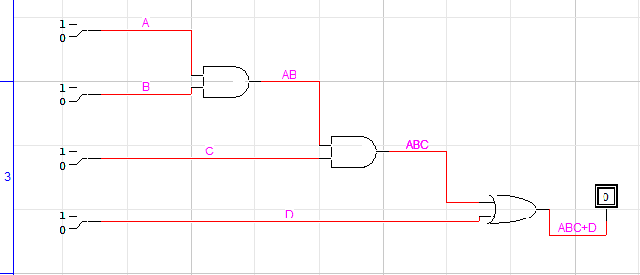

**QUESTION : 05**

**a)**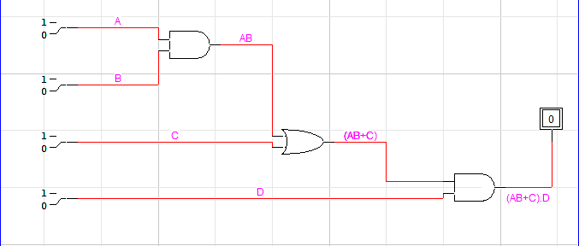

**b)**

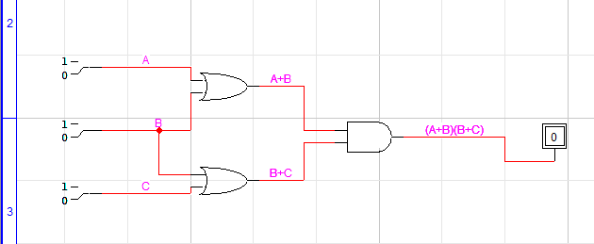

**e)**

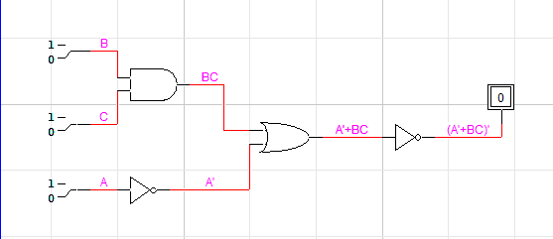

**c)**

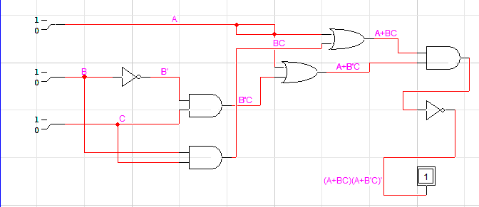

**d)**

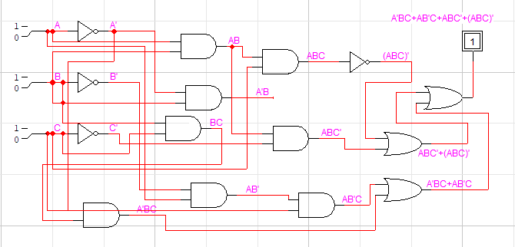

**QUESTION : 03**

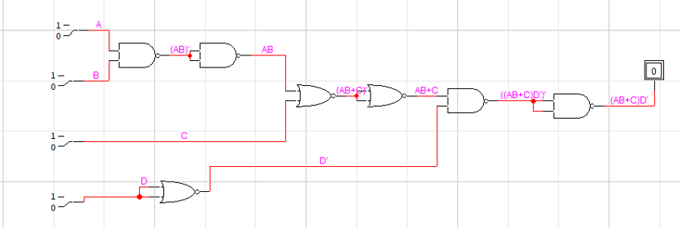

**QUESTION : 04**

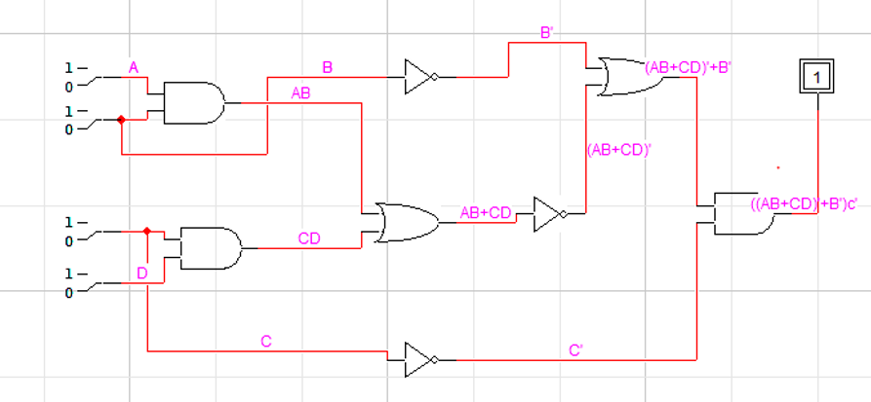

**TRUTH TABLE:**

|  |  |  |  |  |  |  |  |  |  |  |  |
| --- | --- | --- | --- | --- | --- | --- | --- | --- | --- | --- | --- |
| A | B | C | D | AB | CD | AB+CD | (AB+CD)’ | B’ | (AB+CD)’+B’ | C’ | ((AB+CD)’+B’)C’ |
| 1 | 1 | 1 | 1 | 1 | 1 | 1 | 0 | 0 | 0 | 0 | 0 |
| 1 | 1 | 1 | 0 | 1 | 0 | 1 | 0 | 0 | 0 | 0 | 0 |
| 1 | 1 | 0 | 1 | 1 | 1 | 1 | 0 | 0 | 0 | 1 | 0 |
| 1 | 1 | 0 | 0 | 1 | 0 | 1 | 0 | 0 | 0 | 1 | 0 |
| 1 | 0 | 1 | 1 | 0 | 1 | 1 | 0 | 1 | 1 | 0 | 0 |
| 1 | 0 | 1 | 0 | 0 | 0 | 0 | 1 | 1 | 1 | 0 | 0 |
| 1 | 0 | 0 | 1 | 0 | 0 | 0 | 1 | 1 | 1 | 1 | 1 |
| 1 | 0 | 0 | 0 | 0 | 0 | 0 | 1 | 1 | 1 | 1 | 1 |
| 0 | 1 | 1 | 1 | 0 | 1 | 1 | 0 | 0 | 0 | 0 | 0 |
| 0 | 1 | 1 | 0 | 0 | 0 | 0 | 1 | 0 | 1 | 0 | 0 |
| 0 | 1 | 0 | 1 | 0 | 0 | 0 | 1 | 0 | 1 | 1 | 1 |
| 0 | 1 | 0 | 0 | 0 | 0 | 0 | 1 | 0 | 1 | 1 | 1 |
| 0 | 0 | 1 | 1 | 0 | 1 | 1 | 0 | 1 | 1 | 0 | 0 |
| 0 | 0 | 1 | 0 | 0 | 0 | 0 | 1 | 1 | 1 | 0 | 0 |
| 0 | 0 | 0 | 1 | 0 | 0 | 0 | 1 | 1 | 1 | 1 | 1 |
| 0 | 0 | 0 | 0 | 0 | 0 | 0 | 1 | 1 | 1 | 1 | 1 |